1)Alter Table

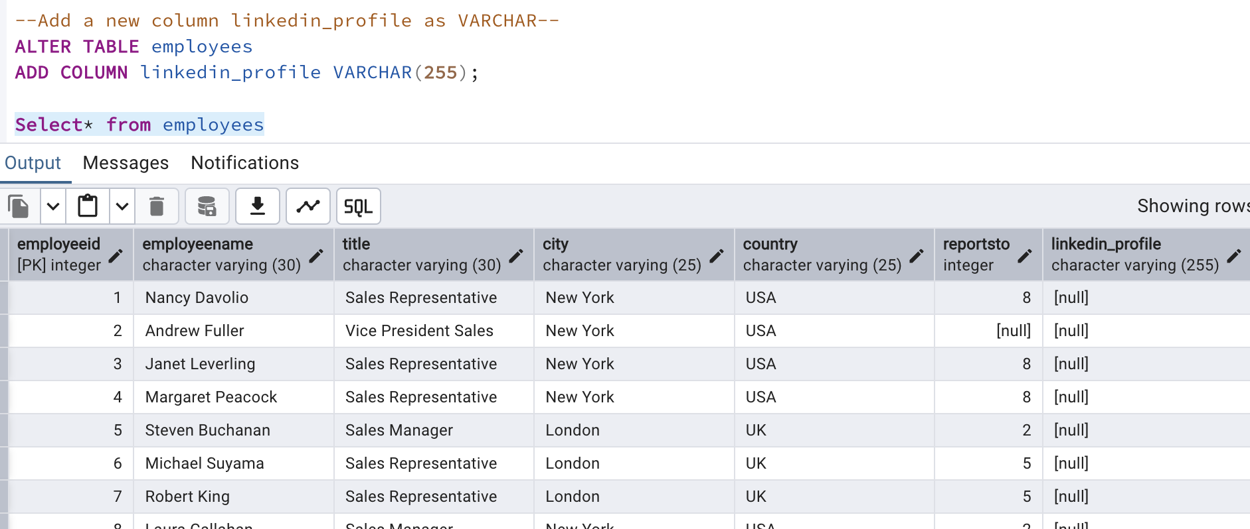

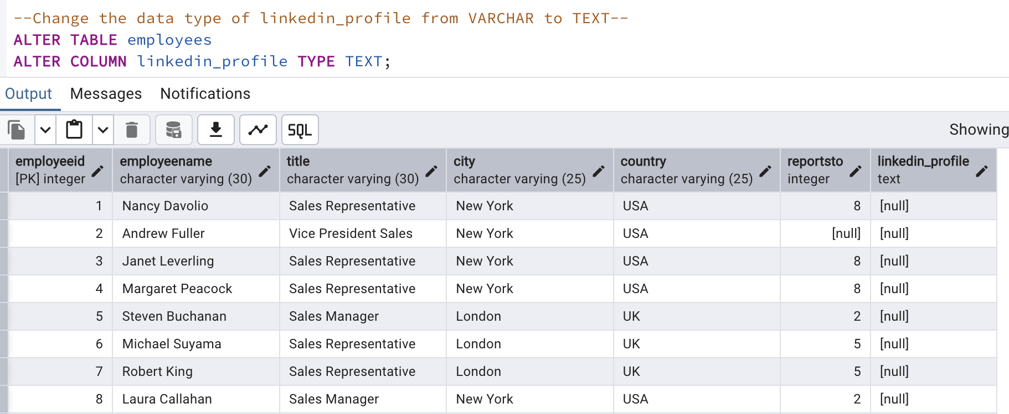

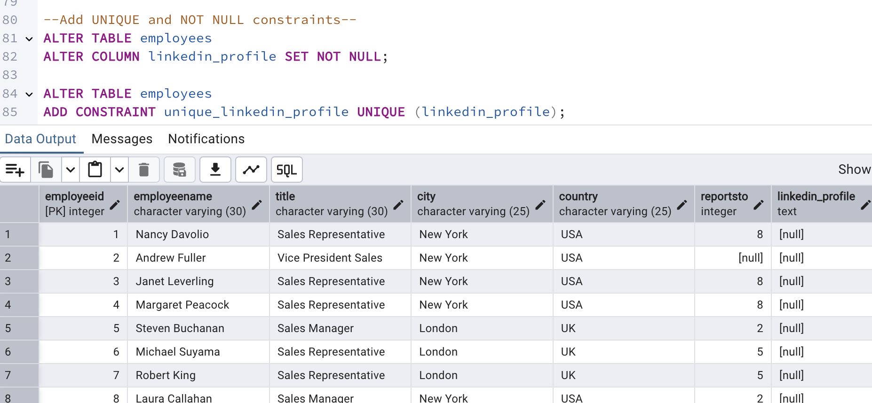

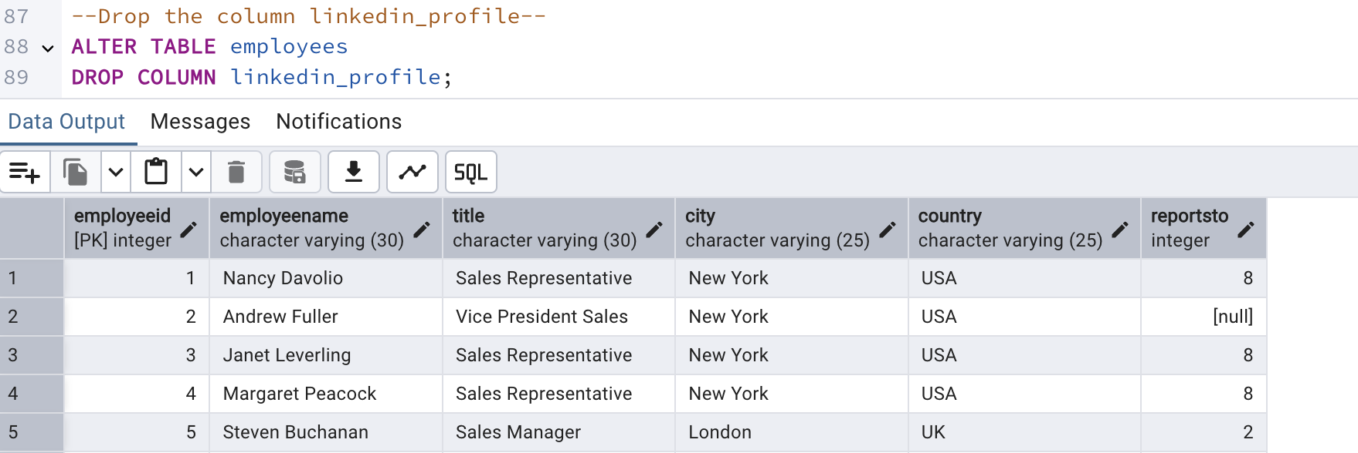

2)Querying (Select)

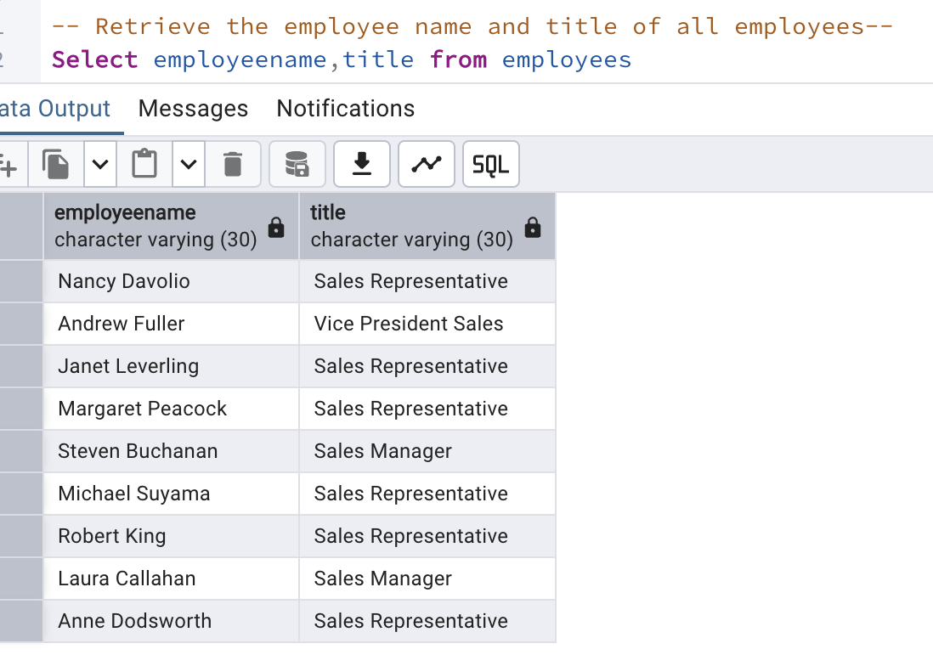

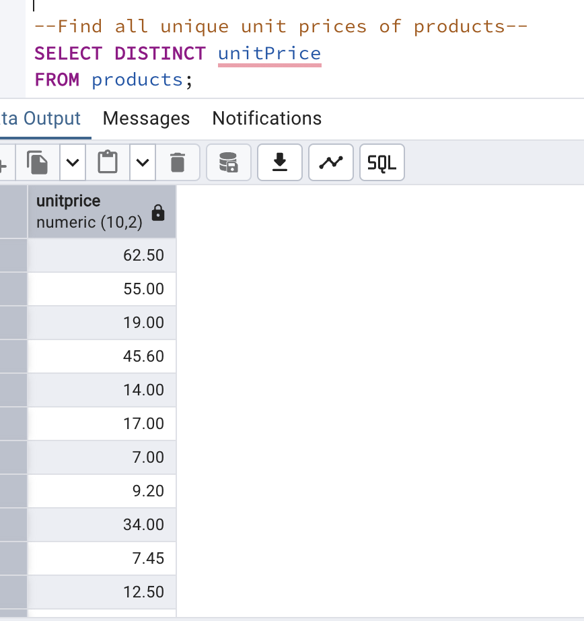

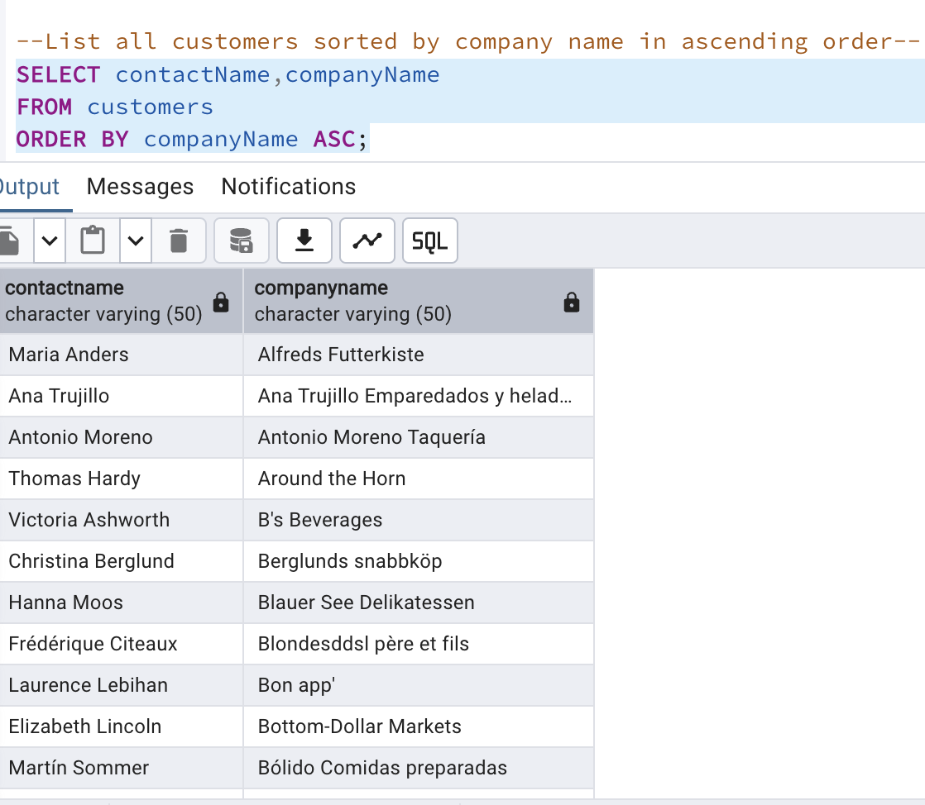

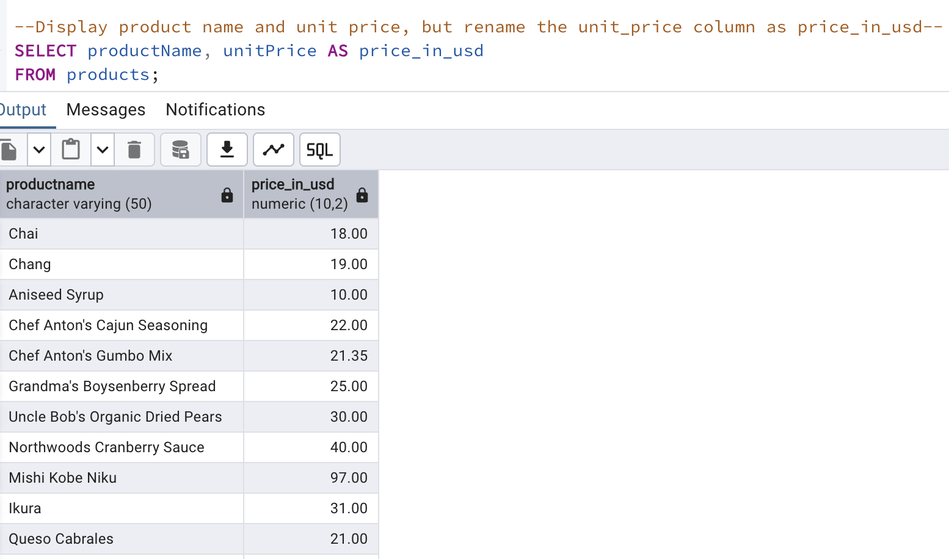

3) Filtering

4)Filtering

5)Limit/Fetch

6)Filtering(In,Between)

7)Filtering

8)Insert into tables

9) Increase(Update)

